Exercise: Interactive component design

**Overview**

In this exercise, you will add an interaction to the UI button component you created in a previous activity in Figma. You can use interactive components to test interactions between variants in a component set. When you add an instance to your designs, those interactions are pre-configured and ready to use.

**Step 1: Open your file**

Open either your button component file or the provided Figma file.

**[C7 M4 L2 item 4 Interactive component](https://d3c33hcgiwev3.cloudfront.net/IbxK6o-4THa8SuqPuOx2Tg_3fe0d3726cd747659f484c2c76a929e1_C7-M4-L2-item-4-Interactive-component-.fig?Expires=1677542400&Signature=QBEEGp2w1rhSFIKsqABmYlBE8cYNdnVQI-hn0k80q8IbNjmcXlEVdVJoCvl5dhAkXznibBHf8j1-jKOTjUHhSRY58idND-NsPIDlAhNEz6N1bfjHZFdA7ctGJhbNov-s8rP7ASMA1jSe5mCUdD4BdKaXfmnplsWH-Sg6nwc8Zzk_&Key-Pair-Id=APKAJLTNE6QMUY6HBC5A" \t "_blank)**

[FIG File](https://d3c33hcgiwev3.cloudfront.net/IbxK6o-4THa8SuqPuOx2Tg_3fe0d3726cd747659f484c2c76a929e1_C7-M4-L2-item-4-Interactive-component-.fig?Expires=1677542400&Signature=QBEEGp2w1rhSFIKsqABmYlBE8cYNdnVQI-hn0k80q8IbNjmcXlEVdVJoCvl5dhAkXznibBHf8j1-jKOTjUHhSRY58idND-NsPIDlAhNEz6N1bfjHZFdA7ctGJhbNov-s8rP7ASMA1jSe5mCUdD4BdKaXfmnplsWH-Sg6nwc8Zzk_&Key-Pair-Id=APKAJLTNE6QMUY6HBC5A" \t "_blank)

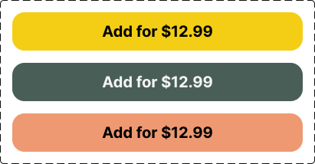

**Step 2: Add interactions**

* Switch to prototype mode on the right-side panel in Figma.

Selection of Prototype

* Select the "default" button; a blue circle should appear.
* Drag this blue circle to the on-click variant button.

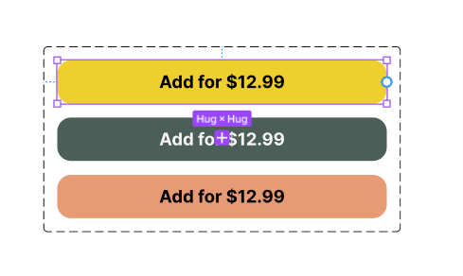

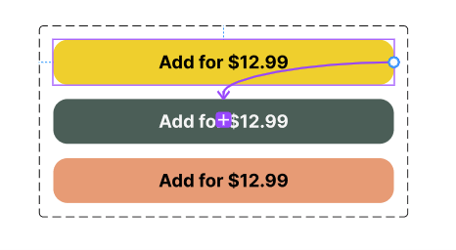

* This will bring up a dialogue panel.

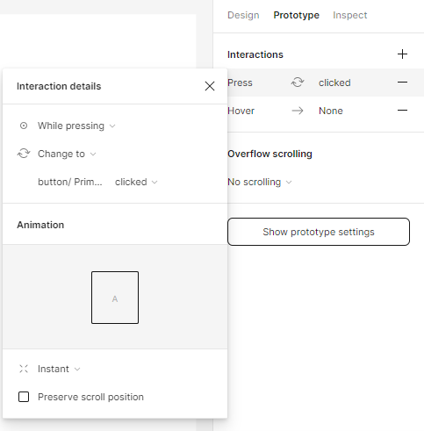

* Change these settings to “while pressing” on the dropdown menu. This action is triggered when you click and hold the mouse or trackpad on a desktop. It can also be triggered when you tap and hold a mobile device.

**Step 3: Test it**

* Go to the assets panel and drag and drop the component onto your frame.
* Select the frame.

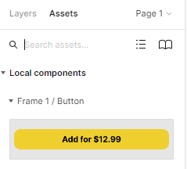

* Head to the right and click the presentation view indicated by an arrow to view the interaction.

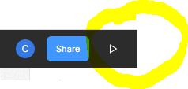

**Step 4: Radio Button**

As per the previous exercise, create a radio button with a variant so users can add an item to customize their order.

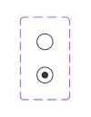

**Step 5: Add interaction to the radio button**

* As with the previous example, add the interaction.

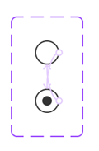

* In the assets panel, you can now see both components.

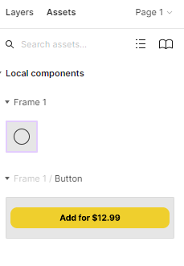

* Drag and drop the component into your frame while holding Alt on windows.
* Click the presentation view indicated by an arrow to view the interaction.

